1. is monitoring defects from the time of recording until satisfactory resolution has been determined
   1. Defect tracking
   2. Quality management
   3. None of the answers is correct
   4. Quality measurement

2. For what level of testing is the following criterion appropriate? No priority 1, 2, or 3 defects are open and all priority 4 defects must have a documented workaround and are accepted by the business

1. Exit from integration testing
2. Entrance to integration criteria
3. Exit from unit criteria
4. Exit from system testing
5. If the project is using highly skilled and experienced developers, what is affected by this factor?
   1. The test reporting
   2. The test strategy
   3. The test automation
   4. The test estimate
6. What is the benefit of independent testing?
   1. Independent testers do not need extra education and training
   2. Independent testers reduce the bottleneck in the incident management process
   3. More work gets done because testers do not disturb the developers all the time
   4. Independent testers tend to be unbiased and find different defects than the developers
7. You are working as a tester on a project to develop a point-of-sales system for grocery stores and other similar retail outlets. Which of the following is a product risk for such a project?
   1. An excessively high number of defect fixes fail during re-testing
   2. The arrival of a more-reliable competing product on the market
   3. Delivery of an incomplete test release to the first cycle of system test
   4. Failure to accept allowed credit cards

6. Increasing the quality of the software, by better development methods, will affect the time needed for testing (the test phases) by

1. Reducing test time
2. It depends on the degree of test independence
3. Increasing test time
4. No change
5. Level of risk is determined by which of the following?
   1. Risk identification and mitigation
   2. Priority and risk rating
   3. Probability and practicality
   4. Likelihood and impact
6. Which of the following is a project risk?
   1. An issue with the interface between the system under test and a peripheral device
   2. A module that performs incorrect calculations due to a defect in a formula
   3. A failed performance test
   4. A problem with the development manager which is resulting in his rejecting all defect reports
7. As a Test Manager you have the following requirements to be tested: Requirements to test:

R1 - Process Anomalies – High Complexity R2 - Remote Services – Medium Complexity R3 – Synchronization – Medium Complexity R4 – Confirmation – Medium Complexity R5 - Process closures – Low Complexity

R6 – Issues – Low Complexity

R7 - Financial Data – Low Complexity R8 - Diagram Data – Low Complexity

R9 - Changes on user profile – Medium Complexity

Requirements logical dependencies (A -> B means that B is dependent on A):

How would you structure the test execution schedule according to the requirement dependencies?

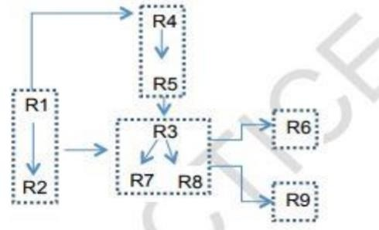

1. R1 > R2 > R3 > R4 > R5 > R7 > R8 > R6 > R9A.R1 > R2 > R4 > R5 > R3 > R7 > R8 > R6 > R9
2. R4 > R5 > R1 > R2 > R3 > R7 > R8 > R6 > R9
3. R1 > R2 > R3 > R7 > R8 > R4 > R5 > R6 > R9
4. R1 > R2 > R4 > R5 > R3 > R7 > R8 > R6 > R9
5. Requirement 24.3. A 'Postage Assistant' will calculate the amount of postage due for letters and small packages up to 1 kilogram in weight. The inputs are: the type of item (letter, book or other package) and the weight in grams. Which of the following conform to the required contents of a test case?
   1. Test 1: letter, 10 grams to Belgium. Test 2: book 500 grams to USA. Test 3: package, 999 grams to South Africa [Req 24.3]
   2. Test 1: letter, 10 grams, postage €0.25. Test 2: book, 500 grams, postage €1.00. Test 3: package, 999 gram, postage €2.53 [Req 24.3]
   3. Test 1: letter 10 grams, Belgium, postage €0.25. Test 2: package 999 grams to South Africa, postage €2.53
   4. Test the three types of item to post and three different weights [Req 24.3]
6. As a test manager you are asked for a test summary report. Concerning test activities, what should you consider in your report?
   1. A summary of the major testing activities, events and its status in respect of meeting goals
   2. Overall evaluation of each development work item
   3. The number of test cases using Black Box techniques
   4. Training taken by members of the test team to support the test effort
7. Which of the following are typical test exit criteria?
   1. Thoroughness measures, reliability measures, test cost, schedule, state of defect correction and residual risks
   2. Thoroughness measures, reliability measures, test cost, time to market and product completeness, availability of testable code
   3. Time to market, residual defects, tester qualification, degree of tester independence, thoroughness measures and test cost
   4. Thoroughness measures, reliability measures, degree of tester independence and product completeness
8. If you are applying risk-based testing, which type of test approach are you using?
   1. Model-based
   2. Analytical
   3. Regulatory
   4. Methodical
9. Which of the following best describes the task partition between test manager and tester?
   1. The test manager plans, monitors and controls the testing activities, while the tester designs tests
   2. The test manager plans testing activities and chooses the standards to be followed, while the tester chooses the tools and controls to be used
   3. The test manager plans, organizes and controls the testing activities, while the tester specifies, automates and executes tests
   4. The test manager plans and organizes the testing and specifies the test cases, while the tester prioritizes and executes the tests
10. Which of the following can be categorized as product risks?
    1. Problems in defining the right requirements, potential failure areas in the software or system
    2. Political problems and delays in especially complex areas in the product
    3. Low quality of requirements, design, code and tests
    4. Error-prone areas, potential harm to the user, poor product characteristics
11. Which of the following is a project risk?
    1. A schedule that requires work during christmas shutdown
    2. A duplicate requirement
    3. An issue with a data conversion procedure
    4. A defect that is causing a performance issue
12. You have received the following description section in an incident report.

The report executed per the attached steps, but the data was incorrect. For example, the information in column 1 was wrong. See the attached screenshot. This report is critical to the users and they will be unable to do their jobs without this information. What is the biggest problem with this incident report?

* 1. The developer won’t be able to see what the tester is saying is wrong
  2. The developer won’t know how important the problem is
  3. The developer won’t know how to repeat the test
  4. The developer doesn’t know what the tester expected to see

1. You have been testing software that will be used to track credit card purchases. You have found a defect that causes the system to crash, but only if a person has made and voided 10 purchases in a row. What would be the proper priority and severity rating for this defect?
   1. Priority high, severity low
   2. Priority low, severity high
   3. Priority high, severity high
   4. Priority low, severity low
2. At what point in the project should the test execution be scheduled?
   1. During test planning
   2. During test implementation
   3. During test execution
   4. During Test Analysis
3. What is the biggest problem with a developer testing his own code?
   1. Developers do not have time to test their own code
   2. Developers are not good testers
   3. Developers are not objective about their own code
   4. Developers are not quality focused
4. A configuration management system would NOT normally provide
   1. the precise differences in versions of software component source code
   2. restricted access to the source code library
   3. facilities to compare test results with expected results
   4. linkage of customer requirements to version numbers
5. You are a tester in a safety-critical software development project. During execution of a test, you find out that one of your expected results was not achieved. You write an incident report about it. What do you consider to be the most important information to include?
   1. Unique id for the report, special requirements needed
   2. Incident description, environment, expected results
   3. Transmitted items, your name and you’re feeling about the defect source
   4. Impact, incident description, date and time, your name
6. Consider the following test cases that are used to test an accounting system:

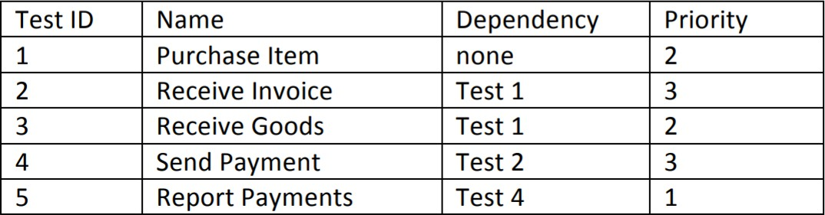

Given this information, what is the proper order in which to execute these test cases?

* 1. 3, 4, 5, 1, 2
  2. 1, 3, 2, 4, 5
  3. 5, 1, 3, 2, 4
  4. 1, 2, 4, 3, 5

1. Which of the following is the most important difference between the metrics based approach and the expert based approach to test estimation
   1. The expert based approach takes longer than the metrics based approach
   2. The metrics based approach can be used to verify an estimate created using the expert based approach, but not vice versa
   3. The metrics based approach uses calculations from historical data while the expert based approach relies on team wisdom
   4. The metrics based approach is more accurate than the expert based approach
2. For a test procedure that is checking modifications of customers on a database, which two steps below would be the lowest priority if we didn't have time to execute all of the steps?
3. Open database and confirm existing customer
4. Change customer's marital status from single to married
5. Change customer's street name from Parks Road to Park Road
6. Change customer's credit limit from 500 to 750
7. Replace customer's first name with exactly the same first name
8. Close the customer record and close the database
   1. Tests 5 and 6
   2. Tests 1 and 4
   3. Tests 2 and 3
   4. Tests 3 and 5
9. A test plan included the following clauses among the exit criteria:

* System test shall continue until all significant product risks have been covered to the extent specified in the product risk analysis document.
* System test shall continue until no must-fix defects remain against any significant product risks specified in the product risk analysis document.

During test execution, the test team detects 430 must-fix defects prior to release and all must-fix defects are resolved. After release, the customers find 212 new defects, none of which were detected during testing. This means that only 67% of the important defects were found prior to release, a percentage which is well below average in your industry. You are asked to find the root cause for the high number of field failures. Consider the following list of explanations:

I Not all the tests planned for the significant product risks were executed.

1. The organization has unrealistic expectations of the percentage of defects that testing can find.
2. A version-control issue has resulted in the release of a version of the software that was used during early testing
3. The product risk analysis failed to identify all the important risks from a customer point of view.
4. The product risk analysis was not updated during the project as new information became available

Which of the following statements indicate which explanations are possible root causes?

* 1. I, IV and V are possible explanations, but II and III are not possible
  2. Ill, IV and V are possible explanations, but I and II are not possible
  3. II, III and IV are possible explanations, but I and V are not possible.
  4. All five are possible explanations

1. Which of the following is a true statement about test planning?
   1. It should be started during design and finished before execution
   2. It should be a continuous activity throughout the project
   3. It should be done at the beginning of the project
   4. It should be used as input for the test strategy
2. Which of the following would NOT normally be a part of a test plan?
   1. Bug reports
   2. Features to be tested
   3. Schedules
   4. Risks
3. What can a risk-based approach to testing help identify?
   1. Role of the test lead for the project
   2. Responsibility for failures that occur in production
   3. Levels of system access to provide to testers
   4. Appropriate testing techniques to use on the system
4. During test execution, the test manager describes the following situation to the project team: '90% of the test cases have been run. 20% of the test cases have identified defects. 127 defects have been found. 112 defects have been fixed and have passed confirmation testing. Of the remaining 15 defects, project management has decided that they do not need to be fixed prior to release.' Which of the following is the most reasonable interpretation of this test status report?
   1. The system is now ready for release with no further testing or development effort
   2. The remaining 10% of test cases should be run prior to release
   3. The remaining 15 defects should be confirmation tested prior to release
   4. The programmers should focus their attention on fixing the remaining known defects prior to release
5. You have been tasked with organizing a set of test cases into a test procedure that will indicate the order in which the test cases will be run. The order of execution is important because you are trying to test end-to-end transactions in this ecommerce book sales application, but you must also consider the priority of the test cases as some are more critical than others.

Given the test cases in this table, what would be the best order for execution to achieve both goals? (Note: 1 is the highest risk)

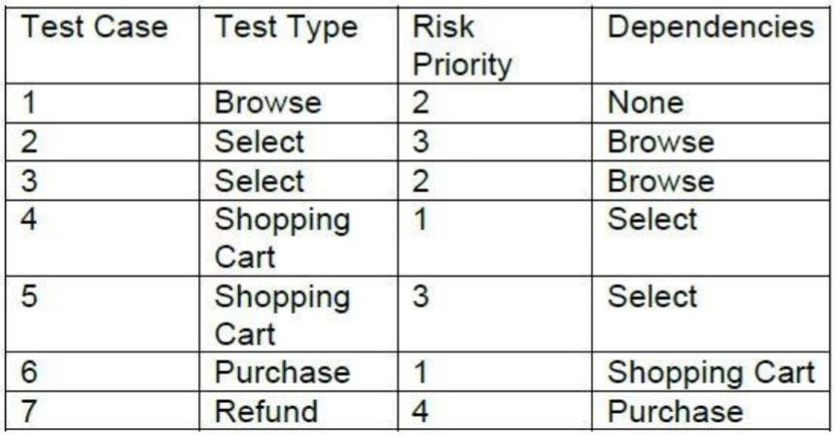

* 1. 1, 2, 5, 6, 7, 1, 3, 4, 6, 7
  2. 4, 6, 1, 3, 2, 5, 7
  3. 1, 3, 2, 4, 5, 6, 7
  4. 1, 3, 4, 6, 1, 2, 5, 6, 7

1. A product risk analysis meeting is held during the project planning period. Which of the following determines the level of risk?
   1. The price for which the software is sold
   2. The harm that might result to the user
   3. The technical staff in the meeting
   4. Difficulty of fixing related problems in code
2. Test objectives vary between projects and so must be stated in the test plan. Which one of the following test objectives might conflict with the proper tester mindset?
   1. Find as many defects as possible
   2. Reduce the overall level of product risk
   3. Show that the system works before we ship it
   4. Prevent defects through early involvement
3. What information need not be included in a test incident report?
   1. How to reproduce the fault
   2. Severity & priority
   3. How to fix the fault
   4. Test environment details
4. Which of the following is a risk that could threaten the project’s objectives?
   1. A data conversion is failing because of an unexpected data format
   2. There are several usability issues in the software
   3. The test environment is not ready
   4. The software fails to detect the selection of an invalid workflow path by a user with restricted rights
5. Why is independent testing important?
   1. Independent testing is usually cheaper than testing your own work
   2. Independent testers are dispassionate about whether the project succeeds or fails
   3. Independent testing is more effective at finding defects
   4. Independent testers should determine the processes and methodologies used
6. Consider the following activities that might relate to configuration management:
7. Identify and document the characteristics of a test item
8. Control changes to the characteristics of a test item
9. Check a test item for defects introduced by a change
10. Record and report the status of changes to test items
11. Confirm that changes to a test item fixed a defect Which of the following statements is true?
    1. Only I is a configuration management task
    2. All are configuration management tasks
    3. I, II, and III are configuration management tasks
    4. I, II, and IV are configuration management tasks
12. Which of the following is a task that a test leader would be expected to do?
    1. Set up test environment
    2. Automate tests
    3. Prepare test data
    4. Write a test strategy
13. Consider the following list of either product or project risks:

I An incorrect calculation of fees might shortchange the organization.

1. A vendor might fail to deliver a system component on time.
2. A defect might allow hackers to gain administrative privileges.
3. A skills gap might occur in a new technology used in the system.
4. A defect-prioritization process might overload the development team.
   1. Ill and V are primarily product risks, while I, II and IV are primarily project risks
   2. I and III are primarily product risks, while II, IV and V are primarily project risks
   3. II and V are primarily product risks and I, III and V are primarily project risks
   4. I is primarily a product risk and II, III, IV and V are primarily project risks
5. If you want to track all changes to versions of your testware, what should you implement?
   1. Test reporting
   2. Configuration management
   3. Tracker control
   4. Test control
6. Which of the following test estimation approaches is based on typical values?
   1. Expert-based
   2. Metrics-based
   3. Value-based
   4. Risk-based
7. Which of the following would be categorized as project risks?
   1. Possible reliability defect (bug)
   2. Poor software characteristics
   3. Skill & Staff shortage
   4. Failure-prone software delivered
8. Which of the following is an advantage of independent testing?
   1. Programmers can stop worrying about the quality of their work and focus on producing more code
   2. The others on a project can pressure the independent testers to accelerate testing at the end of the schedule
   3. Independent testers sometimes question the assumptions behind requirements, designs and implementations
   4. Independent testers don't have to spend time communicating with the project team
9. Which of the following is a drawback with having independent testing done by independent testers?
   1. The testers may be seen as bottlenecks in the release process
   2. The developers will have to do most of the testing anyway
   3. The testers will provide a quality-focused perspective
   4. The developers will have to spend significant time training the testers
10. Which of the following metrics would be most useful to monitor during test execution?
    1. Percentage of test cases written
    2. Percentage of requirements for which a test has been written
    3. Number of test environments remaining to be configured
    4. Number of defects found and fixed
11. Which of the following should include the scheduling of test analysis?
    1. Test strategy
    2. Test Planning
    3. Test Estimation
    4. Test approach
12. Which of the following tasks is most typical for a tester?
    1. Coordinate the testing strategy with project managers
    2. Use test results to guide future planning
    3. Determine what tests should be automated
    4. Acquire and prepare data to be used for testing
13. In an incident report, what is another attribute that can be used to indicate the priority of the incident?
    1. Severity
    2. Urgency
    3. Impact
    4. Risk
14. You have been given the following set of test cases to run. You have been instructed to run them in order by risk and to accomplish the testing as quickly as possible to provide feedback to the developers as soon as possible. Given this information, what is the best order in which to run these tests?

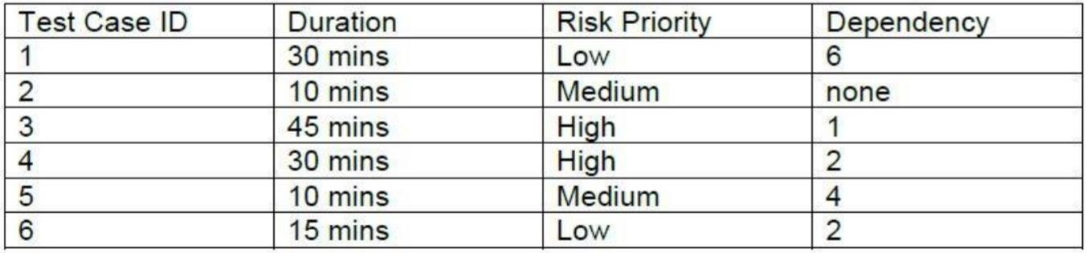

* 1. 2, 4, 5, 6, 1, 3
  2. 6, 1, 3, 2, 4, 5
  3. 4, 3, 2, 5, 6, 1
  4. 2, 5, 6, 4, 1, 3

1. Which of the following encourages objective testing?
   1. Independent Testing
   2. Destructive Testing
   3. Unit Testing
   4. System Testing
2. What is the purpose of tracking defect density?
   1. To determine the number of high priority defects
   2. To predict when the open defects found and the defects fixed numbers will converge
   3. To determine the trend in high severity defects
   4. To determine the areas that have the higher numbers of defects
3. Which of the following documents contains sample test plans?
   1. ISO/IEC/IEEE 29119-3
   2. ISO 1992
   3. ISE / IEC 2187
   4. ISO / IEEE 29113
4. Consider the following exit criteria which might be found in a test plan:

I No known customer-critical defects.

1. All interfaces between components tested.
2. 100% code coverage of all units.
3. All specified requirements satisfied.
4. System functionality matches legacy system for all business rules

Which of the following statements is true about whether these exit criteria belong in an acceptance test plan?

* 1. Only statements I, IV, and V belong in an acceptance test plan
  2. Only statements I, II, and V belong in an acceptance test plan
  3. All statements belong in an acceptance test plan
  4. Only statement I belongs in an acceptance test plan.

1. What is covered in the variances section of the Test Summary Report?
   1. The variances between the weekly status reports and the final summary report
   2. The variances between what was planned for testing and what was actually tested
   3. The variances between the test cases executed and the total number of test cases
   4. The variances between the defects found and the defects fixed
2. Which of the following statements BEST describes how tasks are divided between the test manager and the tester?
3. The test manager plans testing activities and chooses the standards to be followed, while the tester chooses the tools and set the tools usage guidelines.
4. The test manager plans and controls the testing activities, while the tester specifies the tests and decides on the test automation framework.
5. The test manager plans, monitors, and controls the testing activities, while the tester designs tests and decides on the release of the test object.
6. The test manager plans and organizes the testing and specifies the test cases, while the tester prioritizes and executes the tests
7. Which of the following metrics would be MOST useful to monitor during test execution?
8. Percentage of executed test cases.
9. Average number of testers involved in the test execution.
10. Coverage of requirements by source code.
11. Percentage of test cases already created and reviewed
12. Which TWO of the following can affect and be part of the (initial) test planning?
13. Budget limitations.
14. Test objectives.
15. Test log.
16. Failure rate.
17. Use cases
18. Which of the following lists contains only typical exit criteria from testing?
19. Reliability measures, test coverage, test cost, schedule and status about fixing errors and remaining risks.
20. Reliability measures, test coverage, degree of tester’s independence and product completeness.
21. Reliability measures, test coverage, test cost, availability of test environment, time to market and product completeness.
22. Time to market, remaining defects, tester qualification, availability of testable use cases, test coverage and test cost
23. Which one of the following is NOT included in a test summary report?
24. Defining pass/fail criteria and objectives of testing.
25. Deviations from the test approach.
26. Measurements of actual progress against exit criteria.
27. Evaluation of the quality of the test item
28. The project develops a "smart" heating thermostat. The control algorithms of the thermostat were modeled as Matlab/Simulink models and run on the internet connected server. The thermostat uses the specifications of the server to trigger the heating valves. The test manager has defined the following test strategy/approach in the test plan:
29. The acceptance test for the whole system is executed as an experience-based test.
30. The control algorithms on the server are tested during implementation using continuous integration.
31. The functional test of the thermostat is performed as risk-based testing.
32. The security tests of data / communication via the internet are executed together with external security experts.

What four common types of test strategies/approaches did the test manager implement in the test

plan?

* 1. methodical, analytical, reactive and regression-averse.
  2. analytical, model-based, consultative and reactive.
  3. model-based, methodical, analytical and consultative.
  4. regression-averse, consultative, reactive and methodical

1. Which one of the following is the characteristic of a metrics-based approach for test estimation?
2. Budget which was used by a previous similar test project.
3. Overall experience collected in interviews with test managers.
4. Estimation of effort for test automation agreed in the test team.
5. Average of calculations collected from business experts
6. As a test manager you are responsible for testing the following requirements: R1 - Process anomalies

R2 - Synchronization R3 - Approval

R4 - Problem solving R5 - Financial data R6 - Diagram data

R7 - Changes to the user profile

Notation: Logical requirement dependencies (A -> B means, that B depends on A):

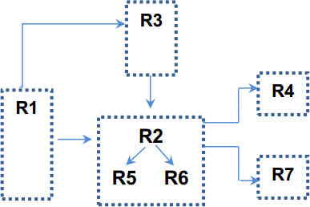

Which one of the following options structures the test execution schedule according to the

requirement dependencies?

1. R1 -> R3 -> R4 -> R7 -> R2 -> R5 -> R6 .
2. R1 -> R3 -> R2 -> R4 -> R7 -> R5 -> R6.
3. R1 -> R3 -> R2 -> R5 -> R6 -> R4 -> R7.
4. R1 -> R2 -> R5 -> R6 -> R3 -> R4 -> R7
5. You are testing a new version of software for a coffee machine. The machine can prepare different types of coffee based on four categories. i.e., coffee size, sugar, milk, and syrup. The criteria are as follows:

* Coffee size (small, medium, large),
* Sugar (none, 1 unit, 2 units, 3 units, 4 units),
* Milk (yes or no),
* Coffee flavor syrup (no syrup, caramel, hazelnut, vanilla).

Now you are writing a defect report with the following information: Title: Low coffee temperature.

Short summary: When you select coffee with milk, the time for preparing coffee is too long

and the temperature of the beverage is too low (less than 40 °C )

Expected result: The temperature of coffee should be standard (about 75 °C). Degree of risk: Medium

Priority: Normal

What valuable information was omitted in the above defect report?

1. The actual test result.
2. Data identifying the tested coffee machine.
3. Status of the defect.
4. Ideas for improving the test case
5. Which of the following BEST explains a benefit of independent testing?
6. The use of an independent test team allows project management to assign responsibility for the quality of the final deliverable to the test team, so ensuring everyone is aware that quality is the test team’s overall responsibility.
7. If a test team external to the organization can be afforded, then there are distinct benefits in terms of this external team not being so easily swayed by the delivery concerns of project management and the need to meet strict delivery deadlines.
8. An independent test team can work totally separately from the developers, need not be distracted with changing project requirements, and can restrict communication with the developers to defect reporting through the defect management system.
9. When specifications contain ambiguities and inconsistencies, assumptions are made on their interpretation, and an independent tester can be useful in questioning those assumptions and the interpretation made by the developer.
10. Which of the following tasks is MOST LIKELY to be performed by the test manager?
11. Write test summary reports based on the information gathered during testing.
12. Review tests developed by others.
13. Create the detailed test execution schedule.
14. Analyze, review, and assess requirements, specifications and models for testability
15. Given the following examples of entry and exit criteria:
16. The original testing budget of $30,000 plus contingency of $7,000 has been spent.
17. 96% of planned tests for the drawing package have been executed and the remaining tests are now out of scope.
18. The trading performance test environment has been designed, set-up and verified.
19. Current status is no outstanding critical defects and two high-priority ones.
20. The autopilot design specifications have been reviewed and reworked.
21. The tax rate calculation component has passed unit testing.

Which of the following BEST categorizes them as entry and exit criteria:

* 1. Entry criteria – 5, 6 Exit criteria – 1, 2, 3, 4
  2. Entry criteria – 2, 3, 6 Exit criteria – 1, 4, 5
  3. Entry criteria – 1, 3 Exit criteria – 2, 4, 5, 6
  4. Entry criteria – 3, 5, 6 Exit criteria – 1, 2, 4

1. 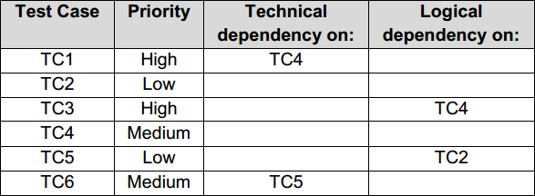Given the following priorities and dependencies for these test cases:

Which of the following test execution schedules BEST considers the priorities and technical and logical dependencies?

1. TC1 – TC3 – TC4 – TC6 – TC2 – TC5
2. TC4 – TC3 – TC1 – TC2 – TC5 – TC6
3. TC4 – TC1 – TC3 – TC5 – TC6 – TC2
4. TC4 – TC2 – TC5 – TC1 – TC3 – TC6
5. Which of the following statements about test estimation approaches is CORRECT?
6. With the metrics-based approach, the estimate is based on test measures from the project and so this estimate is only available after the testing starts.
7. With the expert-based approach, a group of expert users identified by the client recommends the necessary testing budget.
8. With the expert-based approach, the test managers responsible for the different testing activities predict the expected testing effort.
9. With the metrics-based approach, an average of the testing costs recorded from several past projects is used as the testing budget
10. Which of the following BEST defines risk level?
11. Risk level is calculated by adding together the probabilities of all problem situations and the financial harm that results from them.
12. Risk level is estimated by multiplying the likelihood of a threat to the system by the chance that the threat will occur and will result in financial damage
13. Risk level is determined by a combination of the probability of an undesirable event and the expected impact of that event.
14. Risk level is the sum of all potential hazards to a system multiplied by the sum of all potential losses from that system.
15. Which of the following is MOST likely to be an example of a PRODUCT risk?
16. The expected security features may not be supported by the system architecture.
17. The developers may not have time to fix all the defects found by the test team.
18. The test cases may not provide full coverage of the specified requirements.
19. The performance test environment may not be ready before the system is due for delivery
20. Which of the following is LEAST likely to be an example of product risk analysis CORRECTLY influencing the testing?
21. The potential impact of security flaws has been identified as being particularly high, so security testing has been prioritized ahead of some other testing activities.
22. Testing has found the quality of the network module to be higher than expected, so additional testing will now be performed in that area.
23. The users had problems with the user interface of the previous system, so additional usability testing is planned for the replacement system.
24. The time needed to load web pages is crucial to the success of the new website, so an expert in performance testing has been employed for this project.
25. You are performing system testing of a train booking system and have found that occasionally the

system reports that there are no available trains when you believe that there should be, based on the

test cases you have run. You have provided the development manager with a summary of the defect

and the version of the system you are testing. The developers recognize the urgency of the defect and

are now waiting for you to provide more details so that they can fix it. Given the following pieces of information:

1. Degree of impact (severity) of the defect.
2. Identification of the test item.
3. Details of the test environment.
4. Urgency/priority to fix.
5. Actual results.
6. Reference to test case specification.

Apart from the description of the defect, which includes a database dump and screenshots, which of the

pieces of information would be MOST useful to include in the initial defect report?

* 1. 1, 2, 6
  2. 1, 4, 5, 6
  3. 2, 3, 4, 5
  4. 3, 5, 6